**FUND RAISING BY STARTUP**

A startup may need funding for the following reasons, as, Prototype creation, Product development, Team hiring, Working capital, Legal and consulting services, Sales and marketing, Office space and admin expenses, etc.

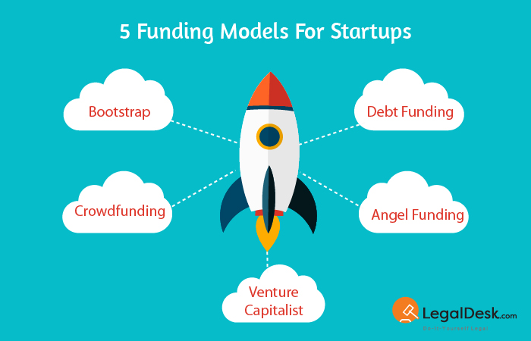

**WHAT IS FUNDING?**

Funding refers to the financial investment of a company to raise money required to start and run a business.

**TYPES OF FUNDING:**

There are three types of startup funding:

1. **Equity funding**

It is where startups give up a portion of their ownership to shareholders in return for capital. Equity Investors prefer to involve themselves in the decision-making process. There is no guarantee in this investment. Sources come from Angel Investors, Self-financing Family and Friends, Venture Capitalists, Crowd Funding.

1. **Debt funding**

It is borrowing money and paying it back with interest within a stipulated time frame. Startups need to provide a business asset as collateral. There is less involvement in decision-making. The lender has no control over business operations. Sources are Banks, Non-Banking Financial Institutions, Government Loan Schemes.

1. **Government grants**

A grant is a financial award given by an entity to a company facilitating a goal or improving performance. There is no component of repayment of the invested funds. Startups pose a huge risk of not receiving a portion of the grant due to several reasons. There is no direct involvement in decision making. Sources are Central Government, State Governments, Corporate Challenges, Grant Programs of Private Entities.

**INVESTORS SEARCH FOR…**

* **Objective and Problem Solving**

The offering of any startup must be unique to meet specific customer needs of which patented ideas or products have high growth potential.

* **Management & Team**

The passion, experience, and skills of the founders as well as the management team to further improve the company.

* **Scalability & Sustainability**

Startups should have the potential to scale a sustainable and stable business plan, considering barriers to entry, imitation costs, growth rate, and expansion plans.

* **Customers & Suppliers**

Clear identification of buyers and suppliers.

* **Competitive Analysis**

A true picture of competition and other players in the market working on similar things should be highlighted.

* **Sales & Marketing**

No matter how good the service may be, it is total waste if there is no end-use. Sales forecast, targeted audiences, product mix, conversion and retention ratio, etc play a major role.

* **Financial Assessment**

A detailed and a reasonable financial business model showcasing cash inflows over the years, investments and growth rates.

**STEPS IN STARTUP FUND RAISING:**

* **[Assessing Need for Funding](https://www.startupindia.gov.in/content/sih/en/funding.html" \l "5423070839462048-0)**

The startup needs to assess why funding is required, identify the right amount to be raised along with a milestone-based plan stating what the startup wishes to do in the upcoming years.

* **[Assessing Investment Readiness](https://www.startupindia.gov.in/content/sih/en/funding.html" \l "5423070839462048-1)**
* It is important to understand if the startup is ready to raise funds. Any investor will take the startup seriously, if they are convinced about the revenue projections and their returns.
* **[Preparation of Pitchdeck](https://www.startupindia.gov.in/content/sih/en/funding.html" \l "5423070839462048-2)**

A pitchdeck is a detailed presentation about the important aspects of the startup. Creating an investor pitch is all about telling a good story connecting each element with the other.

* **[Investor Targeting](https://www.startupindia.gov.in/content/sih/en/funding.html" \l "5423070839462048-3)**

Every Venture Capitalist Firm has an Investment Thesis which is a strategy that identifies stage, geography, focus of investments, and differentiation of the firm. To target the right set of investors, it is necessary to research Investment Thesis, their past investments in the market, and speak with entrepreneurs who have successfully raised equity funding.  This exercise will help to identify active investors, their sector preferences, geographic location, average ticket size of funding and level of engagement and mentor-ship provided to investing startups.

* **[Due Diligence by Interested Investors](https://www.startupindia.gov.in/content/sih/en/funding.html" \l "5423070839462048-4)**

Angel networks and Venture Capitalists conduct a thorough due diligence of the startup before finalizing any equity deal looking at the startup’s past financial decisions and the team’s credentials as well as its background to ensure the startup’s claims regarding the growth and market numbers can be verified and identify objectionable activities beforehand. If the due diligence is a success, the funding is finalized and completed on mutually agreeable terms.

* **[Term Sheet](https://www.startupindia.gov.in/content/sih/en/funding.html" \l "5423070839462048-5)**

A term sheet is a “Non-binding” list of propositions by a venture capital firm at the early stages of a deal that summarizes major points of engagement in the deal between the investing firm and the startup. A term sheet for a venture capital transaction in India typically consists of four structural provisions.

1. **Valuation**

Startup valuation is the total worth of the company as estimated by a professional valuer.

1. **Investment Structure**

It defines the mode of the venture capital investment in the startup, whether it is through equity, debt, or a combination of both.

1. **Management Structure**

It includes a list for the board of directors, and prescribed appointment and removal procedures.

1. **Changes to share capital**

All investors in startups have their investment timelines, and accordingly they seek flexibility while analyzing exit options through subsequent rounds of funding.